Player Registration
………………………………………………………………………Tear at perforation……………………………………………………………………….
1
Name

Address

City/State/Zip

Phone

Email
2

Name

Address

City/State/Zip

Phone

Email
3

Name
Address

City/State/Zip

Phone

Email
4

Name

Address

City/State/Zip

Phone

Email

Event Information

Monday, May 21, 2018
The Golf Club at Yankee Trace
10000 Yankee St. Centerville, OH 45458

11:00am Registration and Lunch

12:00pm Shotgun Start – 18 hole Scramble

5:30pm Dinner in the clubhouse

Awards & Prizes presented at Dinner

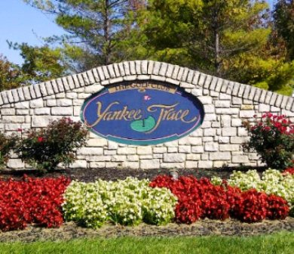
$125per person
Includes: Golf, Lunch & Dinner
Sign up in 4 person teams.
(If you do not have a team you will be assigned to one)

For more info contact:

Brendan Cunningham
937-477-1824
brendan@tjsplaceofhope.org

www.tjsplaceofhope.org

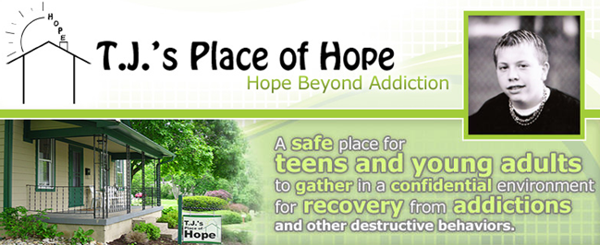

6th Annual Golf Scramble
“Hope Beyond Addiction”
Monday, May 21, 2018

Event Located at:

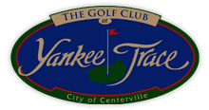
10000 Yankee St.
Centerville, OH 45458

Proceeds to benefit:
T.J.’s Place of Hope
Non-profit # 06-1780173

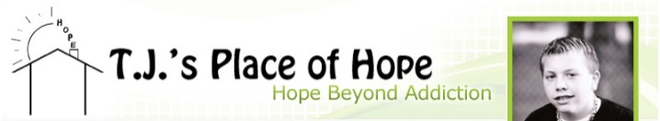

T.J.’s Place of Hope is located in Centerville, OH

T.J. Whitehead was just 18 years of age when he took his own life after battling drug and alcohol addiction for the majority of his adolescant life. T.J.’s Place of Hope was created in his memory.

T.J.’s Place of Hope is an organization of compassionate people helping teens and young adults battling addiction and destructive behaviors to realize their full potential and dreams! T.J.’s is a unique place where teens and young adults can support AND receive support from others their own age. They can also attend meetings facilitated by an experienced adult; many recovering addicts themselves that understand what they are going through and their challenges.

Our goal is to encourage these young men and women to grow and heal while fostering and nurturing their observed creative, natural talents (for example Art & Music). A main component of our mission is to move them through addictive & suicidal episodes with short term distractions while teaching them long term coping mechanisms. We also help family and friends find treatment solutions for their teens and welcome those who are not addicted themselves, but are impacted by affected family members or friends.

Sponsorship Levels
TITLE SPONSOR $2,500
(2) Foursomes
Sponsorship of (9) holes
(4) Additional guests at dinner
Display banner at registration
Display banner at dinner
Provide printed materials in gift bag
Recognition in golf program
GOLD SPONSOR $1,250
(1) Foursomes
Sponsorship of (4) holes
(4) Additional guests at dinner
Recognition in golf program
HOLE SPONSOR $100
Sponsorship of (1) holes
Other Sponsorship Opportunities:
Dinner Sponsorship $750
Lunch Sponsorship $500
Gift Bag Sponsorship $500
Hole in One Sponsorship $300

- $100 per person Includes: Golf, Lunch & Dinner
Sign up in 4 person teams (If you do not have a team you will be assigned to one)
- $50 per person Non-Golfer dinner

$125 per person
Includes: Golf, Lunch & Dinner!
$50 per person Non-golfer dinner

Thank you to all of our community partners and volunteers who faithfully support the mission and vision of
T.J.’s Place of Hope.

Register and Pay online:
www.tjsplaceofhope.org

or by Mail:

Please make checks payable to:

T.J.’s Place of Hope
PO Box 750964
Centerville, OH 45475

Payment Information

Name

Company

Address

City/State/Zip

Phone

Email

Amount Total $ ____________________

