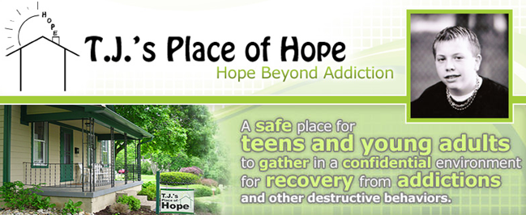
“Hope Beyond Addiction”
Monday, May 21, 2018

6th Annual Golf Scramble
T.J. Whitehead was just 18 years of age when he took his own life after battling drug and alcohol addiction for the majority of his adolescant life. T.J.’s Place of Hope was created in his memory.

T.J.’s Place of Hope is an organization of compassionate people helping teens and young adults battling addiction and destructive behaviors to realize their full potential and dreams! T.J.’s is a unique place where teens and young adults can support AND receive support from others their own age. They can also attend meetings facilitated by an experienced adult; many recovering addicts themselves that understand what they are going through and their challenges.

Our goal is to encourage these young men and women to grow and heal while fostering and nurturing their observed creative, natural talents (for example Art & Music). A main component of our mission is to move them through addictive & suicidal episodes with short term distractions while teaching them long term coping mechanisms. We also help family and friends find treatment solutions for their teens and welcome those who are not addicted themselves, but are impacted by affected family members or friends.
Sponsorship Levels | EVENT INFORMATION | 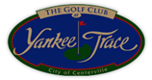
TITLE SPONSOR $2,500 | The Golf Club at Yankee Trace
(2) Foursomes | 10000 Yankee St. Centerville 45458
Sponsorship of (9) holes
(4) Additional guests at dinner | 11:00am Registration | Awards & Prizes  Presented at Dinner:
Display banner at registration | 11:00am Lunch
Display banner at dinner | 12:00pm Shotgun Start – 18 hole scramble | 1st & 2nd place team
Provide printed materials in gift bag | 5:30pm Dinner in the clubhouse | $10,000 Hole in One
Recognition in golf program |  | Longest Drive  Closest to Pin
GOLD SPONSOR $1,250 |  | 50/50 & Prize raffle
(1) Foursomes
Sponsorship of (4) holes | Online Golfer Registrations | For more info contact:
(2) Additional guests at dinner | can be made on our Website: | Brendan Cunningham
Recognition in golf program | www.tjsplaceofhope.org | 937-477-1824
HOLE SPONSOR $100 | brendan@tjsplaceofhope.org
Sponsorship of (1) hole |  | www.tjsplaceofhope.org
Other Sponsorship Opportunities | All proceeds to benefit: T.J.’s Place of Hope
Dinner Sponsorship $750 |  | Non profit # 06-1780173
Lunch Sponsorship $500 | - $125 per person Includes: Golf, Lunch & Dinner  Sign up in 4 person teams (If you do not have a team you will be assigned to one)  - $50 per person Non-Golfer dinner
Gift Bag Sponsorship $500
Hole in One Sponsorship $300

